**SECONDS CONVERTOR**

**CODING**

#include<iostream>

#include<conio.h>

using namespace std;

void main()

{

int s;

cout<<"Don't enter less than 60 Seconds \n";

cout<<" Enter No of Seconds : ";

cin>>s;

if(s>60 && s<3600)

{

s=s/60;

cout<<"\n"<<s <<" : Minutes in this second "<<endl;

}

else if(s>=3600 && s < 86400)

{

s=s/3600;

cout<<"\n " <<s <<" Hours in this second "<<endl;

}

else if(s>=86400 && s <2592000 )

{

s=s/86400;

cout<<"\n "<<s <<" Days in this seconds"<<endl;

}

else if(s>=2592000 && s <31536000 )

{

s=s/2592000;

cout<<"\n "<<s <<" Months in this seconds "<<endl;

}

else if(s>=31536000)

{

s=s/31536000;

cout<<"\n "<<s <<" Years in this seconds "<<endl;

}

getch();

}

OUTPUT

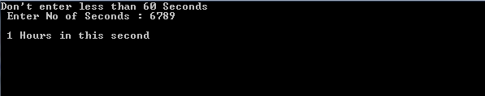

**BILL**

**CODING**

#include<iostream>

#include<conio.h>

using namespace std;

void main()

{

float a1,a2,a3,a4,a5,total,meter,tax;

cout<<"....BILL...\n";

a1=1*100;

cout<<"For 100 units : Your amount is :"<<a1<<endl;

a2=2*100;

cout<<"For next 100 units : Your amount is :"<<a2<<endl;

a3=3*100;

cout<<"For next 100 units : Your amount is :"<<a3<<endl;

a4=4*100;

cout<<"For next 200 units : Your amount is :"<<a4<<endl;

a5=5*100;

cout<<"For next units : "<<a5 <<endl;

tax=0.1;

meter=50;

cout<<endl;

total=a1+a2+a3+a4+a5+50+0.1;

cout<<"Total bill is :"<<total <<"\t"<<"Meter charge and tax is included ";

getch();

}

OUTPUT

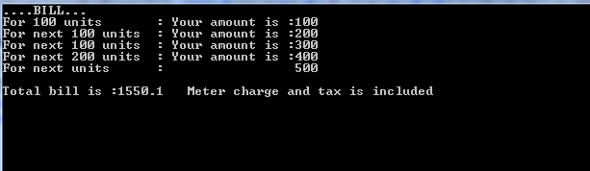

SALES TAX CALCULATOR

CODING

#include<iostream>

#include<conio.h>

using namespace std;

void main()

{

float a,st; //amount,sale tax

cout<<"......To calculate the sales tax on your property....\n";

cout<<endl;

cout<<"Enter the amount on which u apply tax ?";

cin>>a;

st=a*(0.02/100);// here 2% tax applyable

cout<<"The sale tax is: "<<st <<"%";

getch();

}

**OUTPUT**

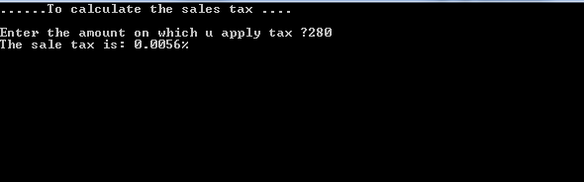

**SELLING PRICE CALCULATOR**

**CODING**

#include<iostream>

#include<conio.h>

using namespace std;

void main()

{

float sp,profit,cp;

cout<<"......To calculate the selling price of circuit board......\n";

cout<<endl;

cout<<"the cost price of circuit board is : $12.67 \n"; //before profit

cp=12.67;

profit=0.4*cp;

sp=cp+profit;

cout<<"The selling price of circuit board that costs $12.67 is : $"<<sp;

getch();

}

**OUTPUT**

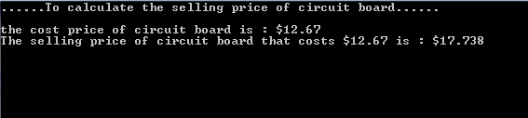

**THE CUBE OF NUMBER**

#include<iostream>

#include<conio.h>

using namespace std;

void main()

{

int cube,num;

cout<<"====calculate the cube of number==== \n";

while(1)

{

cout<<" Enter a number to find the cube\n ";

cin>>num;

cube=(num*num*num);

if(num %2==0 && num %3==0)

{

break;

}

cout<<"cube is="<<cube <<endl;

}

getch();

}

**OUTPUT**

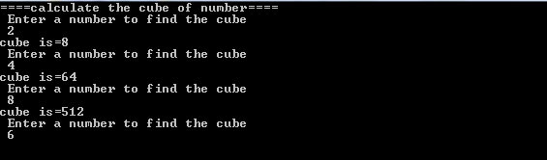

**REATURANT BILL**

**CODING**

#include <iostream>

#include<conio.h>

using namespace std;

void main()

{

float meal = 44.50;

float tax = 0.0675 * meal;//tax including meal amount

float tip =(tax + meal)*0.15;

float final_amoun= meal + tax + tip; // total amount including tip+tax+meal

cout<<"..........Resturant Bill...........\n";

cout<<endl;

cout << "Meal charge \t$"<<meal << endl;

cout << "Tax amount \t$"<< tax<< endl;

cout << "Tip amount \t$"<< tip << endl;

cout << "Total amount \t$"<< final_amoun << endl << endl;

getch();

}

**OUTPUT**

